Learning Objective
We are learning how to use a colon to introduce a list.

Challenge 1
Correct the following sentences by inserting the necessary punctuation marks.
- The following foods feature heavily in an Indian giant squirrel’s diet fruit flowers nuts and tree bark.
- Indian giant squirrels have a number of interesting physical features a brush-like tail, multi-coloured fur and sharp claws.
- Indian squirrels can be found in several regions of India the Western Ghats (mountains) the Eastern Ghats and the Satpura hills.
- The multi-coloured fur coat of an Indian giant squirrel can feature a variety of colours deep red orange purple beige and brown.
- Animals fall into three different groups based on what they eat meat-eating carnivores
plant-eating herbivores and omnivores (animals that have a diet of meat and plants).

Challenge 2
Rewrite each of the sentences below so that a colon introduces the list. Remember – your introductory clause must be able to stand alone as a sentence. Furthermore, when rewriting the sentences, remove the unnecessary ‘ands’ and replace them with the correct punctuation marks.

- The four species of giant squirrel are the Indian giant squirrel and the grizzled giant squirrel and the black giant squirrel and the cream-coloured giant squirrel.
- Dam construction and poaching and logging and deforestation all pose a threat to the Indian giant squirrel’s existence.
- Indian giant squirrels are often described as being cute and clever and curious.
- Scent marking and tail twitching and making a variety of vocal sounds are the different ways in which Indian giant squirrels communicate.

Challenge 3
You have been asked to write an article for a wildlife magazine that describes the appearance, behaviour and habitat of the Indian giant squirrel. Your article should include some of the words from the Word Wall and at least two sentences that use a colon to introduce a list.

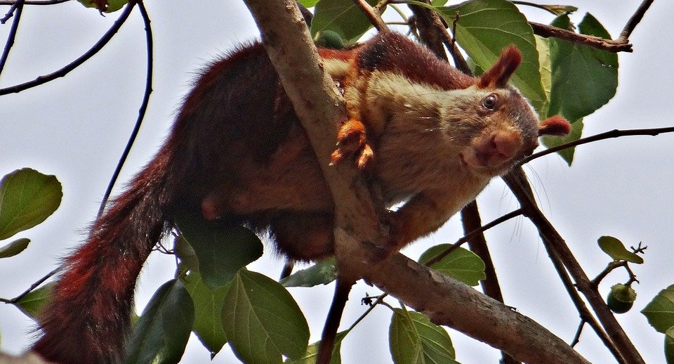
Word Wall
curious, cute, clever
endangering
human threats
deforestation, dam construction, logging, poaching
rodent
scent marking, tail twitching, vocal noises
communicate
Indian giant squirrel
Malibar squirrel

