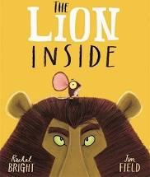
Thursday 7th January
Pathways
In Pathways this half term, our focus book is The Lion Inside. For our first pathways lesson, we will read the story and then discuss it. These are the questions we will be focusing on before reading the story:
Questions to discuss before we read The Lion Inside...
- What do you think this story might be about? Why?
- What characters might we meet in this story?
- Can anyone tell me the author of this story?
- Let's discuss the front cover, the back cover and the title.
- What do we call that writing on the back cover?
- What does the title tell us about the story?
- Do we think this is a fiction or non-fiction book? Why?

We will also be discussing the story as we read it, including key vocabulary. You will be able to see this on our live lesson.
If you would like to listen to the story again, you can either re-watch the live lesson, or you can follow this link to hear it on YouTube: https://www.youtube.com/watch?v=3h5axPgsfSk

Thanks,

Miss Peel

