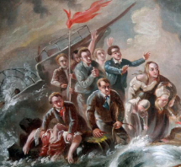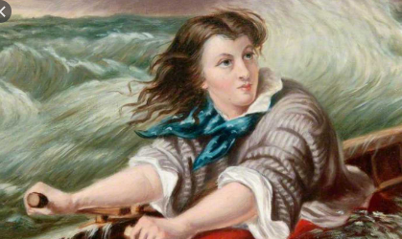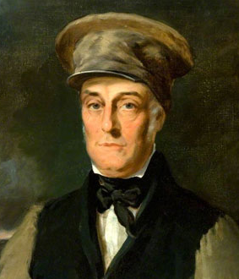  
Grace Darling

Survivors of the Forfarshire

The Rescue of the Forfarshire

7th September 1838

William Darling